Testing Plan Summary and Test 1.1 Results

## Team 34: PUCKFish

Team Lead 5:Victoria Thomas

Will Aracri, Alex Neckakov, Peter Ha, Ammar Hussain

# Contents

**Title Page 1**

**Contents** **2**

**Introduction** **3**

**Testing Plan Overview** **4**

**Test Overview** **5**

Test 1: Water-Proofing and Data Collection 5

Test 2.1: IMU Proof of Concept 5

Test 2.2: Sensor Array Test 6

Test 3.1: Port and Enclosure Testing 6

Test 3.2: Full Hardware Test 6

Test 4: Full PUCKFish Test 6

**Test 1.0** **7**

**Introduction and Overview** **7**

**Summary of Procedure and Required Equipment** **7**

**Results** **9**

Conclusion 10

Testing Plan

# Introduction

PUCKFish is a device containing sensors (Temperature, Dissolved Oxygen, Salinity, Current Velocity, Depth, Ambient Light) to be mounted on top of lobster traps in order to monitor the best possible locations to place traps for maximum catch yield. In order to function, the device must operate under water at depths of up to 1100 feet and then transmit data wirelessly to a base station upon retrieval.

In order to properly test PUCKFish to determine its effectiveness as well as aid in the design interaction process, the team considered the major challenges of the project and then broke them down into testable conditions. These attributes are as listed below.

Major Challenges and Required Testing Capabilities include:

1. Sensor Arrays and Related Electronics: All sensors (accelerometer, light sensor, temperature sensor, orientation sensor, and radio transmitter) must be tested with related electronic elements to ensure the required accuracy and precision metrics are achieved
2. Device Body durability: Ensure that the skeleton of PUCKfish can be properly cast in epoxy within a 3D printed or silicone mold

By considering the major challenges above, a testing plan as well as a general technical development plan could be developed and executed.

# Testing Plan Overview

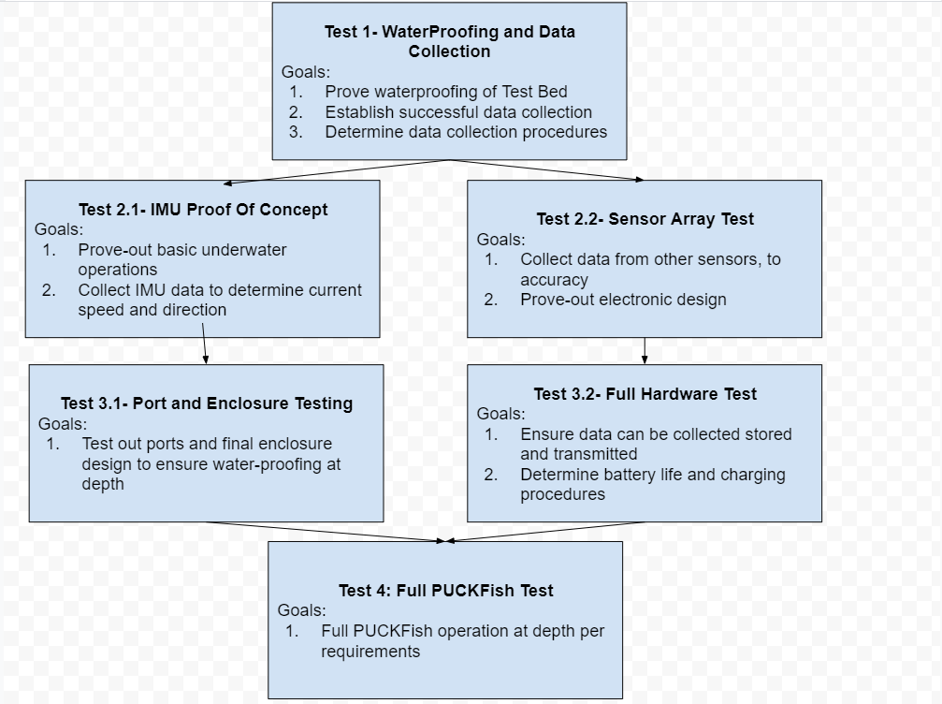

*Figure 1: Testing Plan*

The overall testing plan involves 6 separate tests with goals that build upon each other to achieve the end result of a final operational test with PUCKFish. Included in the testing plan were requirements for the team’s structure as to eliminate blockers and keep work progressing.

The plan involves an initial step proving how the team can come together to perform a successful test. It then moved into two parallel paths that developed the electronic systems and mechanical systems in tandem. By creating parallel paths, the team believes that PUCKFish can be developed in a shorter amount of time while continuously proving out technologies required for the next stage. These small proof of concepts allow for minimal risk in carrying out electronic tests in the water as to limit the possibilities of hardware damage or failures.

Additionally, the goals of each test will be refined as data is collected from tests earlier in the testing plan, allowing for more targeted objectives and quantifiable testing requirements. Specific procedures for each test will be developed based upon knowledge gained from previous tests. This will allow more streamlined testing as well as refining the actual test environment to achieve the required metrics.

# Test Overview

Each test with their accompanying goals is outlined below. Where applicable, if a test requires data or knowledge from a test prior in the testing plan, a description is provided with how these requirements will be developed.

## Test 1: Water-Proofing and Data Collection

The major goals of Test 1 are as follows.

1. Prove waterproofing of Test Bed
   1. The test bed of the PUCKFish is a waterproof enclosure designed to test systems under-water without development time of producing a final enclosure design. This additionally demonstrates how the mechanical engineering subteam can design an enclosure to withstand low-depth submersion in water.
2. Establish successful data collection
   1. Establishing data collection is essential to determine how to transmit data to the base station. In addition, data collection remotely will be of use in later tests where depth is lower and adjustments to the testing environment can be made on the fly without removing the electronics and checking the hardware itself.
3. Determine Data Collection Procedures
   1. By determining data collection procedures, the team can share a common resource that does not require explanation or full team attendance to successfully run a test. This provides faster data collection and more refined technical developments in future tests.

## Test 2.1: IMU Proof of Concept

The major goals of Test 2.1 are as follows

1. Prove-Out basic underwater operations
   1. The IMU test bed will take place in a body of water with some current velocity and at a more significant water depth. This experience will allow the team to better understand how to operate and contend with running tests underwater which will be paramount for further development.
2. Collect IMU Data to determine current speed and direction
   1. After developing a model for how to produce an orientation from IMU data, the team can create models based upon flow around the PUCKFish to determine current speed and velocities. Proving these models work is paramount to the final success of PUCKFish.

## 

## Test 2.2: Sensor Array Test

The major goals of test 2.2 are as follows

1. Collect data from other sensors to accuracy
   1. Collecting the data from the sensors, excluding the IMU, will allow the team to determine how to get data form the sensors and if the sensors achieve the necessary grades of precision and accuracy.
2. Prove-out electronic design
   1. In order to collect data from the sensors, there must be something to read and translate the data to be read. This hardware setup will allow the team to gain experience with building out the necessary electronic set up as well as proving out technology in design.

## Test 3.1: Port and Enclosure Testing

The major goals for test 3.1 are as follows

1. Test out ports and final enclosure design to ensure water-proofing at depth
   1. Using experience from tests 1.1 and 2.1, test 3.1 allows for testing the enclosure at depth without electronics to determine waterproofing. In addition, somes sensors require exposure to the water surrounding the enclosure, to do this PUCKFish uses ports to the outside. It is important to determine that ports can do this successfully without letting water into the enclosure.
   2. Prove effectiveness of final silicone mold and the parts it casts

## Test 3.2: Full Hardware Test

The major goals for Test 3.2 are as follows

1. Ensure data can be collected stored and transmitted
   1. The final PUCKFish must be able to store and transmit full data sets. Prior tests do not require this capability, so it must be proved here.
2. Determine Battery Life and Charging procedures
   1. Prior tests do not require the battery life and charging to accomplish them. In order to prove the batteries capabilities, this will be proven here.

## Test 4: Full PUCKFish Test

The major goals for Test 4 are as follows

1. Full Operation at Depth
   1. This test is the final test for PUCKFish. It includes all of the prior test’s requirements and should reach full operation or the path to full operation.

After determining the testing plan and each test and their goals, the team was prepared to run Test 1: WaterProofing and Data Collection

# Test 3.1: Partial Enclosure Testing

# Introduction and Overview

The goals for this test are as follows:

1. Epoxy successfully cures in mold

Previously, we had attempted to cast the PUCKfish skeleton in epoxy in an ABS mold. Unfortunately, the epoxy bled directly into the ABS mold. This was an unanticipated result. Instead, we came up with two possible solutions: improve the current casing design or create a new method of casting. We felt that by pursuing these two methods at the same time, we would be prepared if one failed. To amend the existing ABS mold, we coated the inside of the mold with waterproof enamel. However, this still produced minor bleeding. To mitigate this, we applied a thin plastic sheet to the inside of the mold. While there was minor bleeding into the skeleton, as it is also made of ABS, this solution was successful.

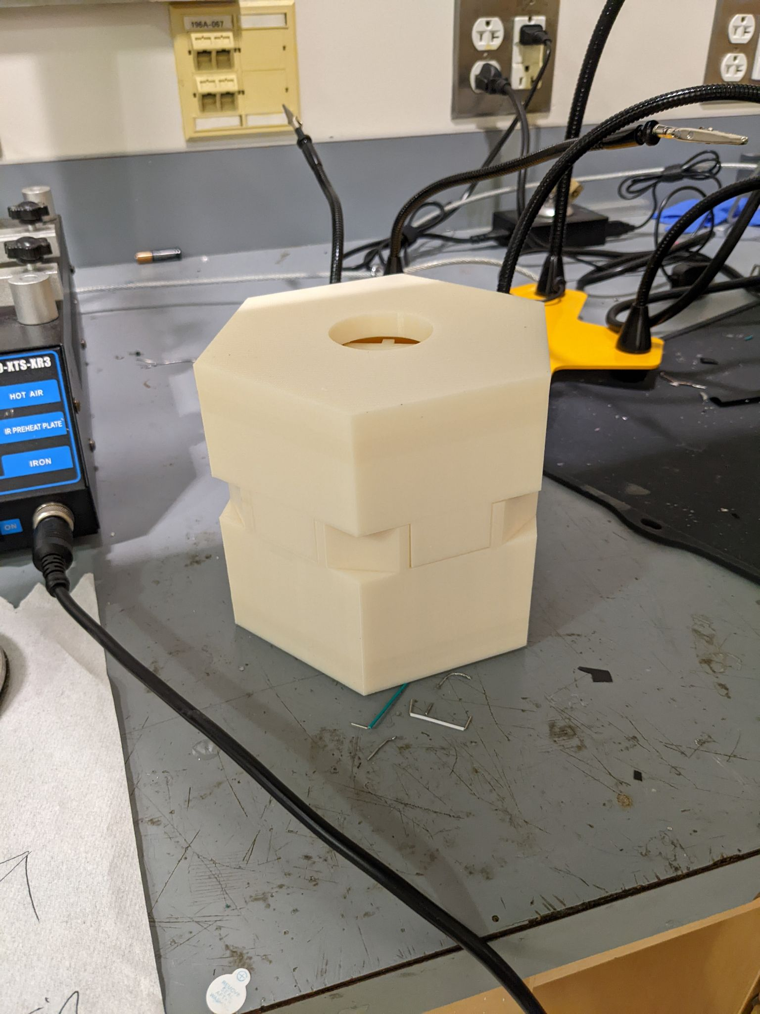

*Figure 2: Initial, Untreated 3D Printed Mold*

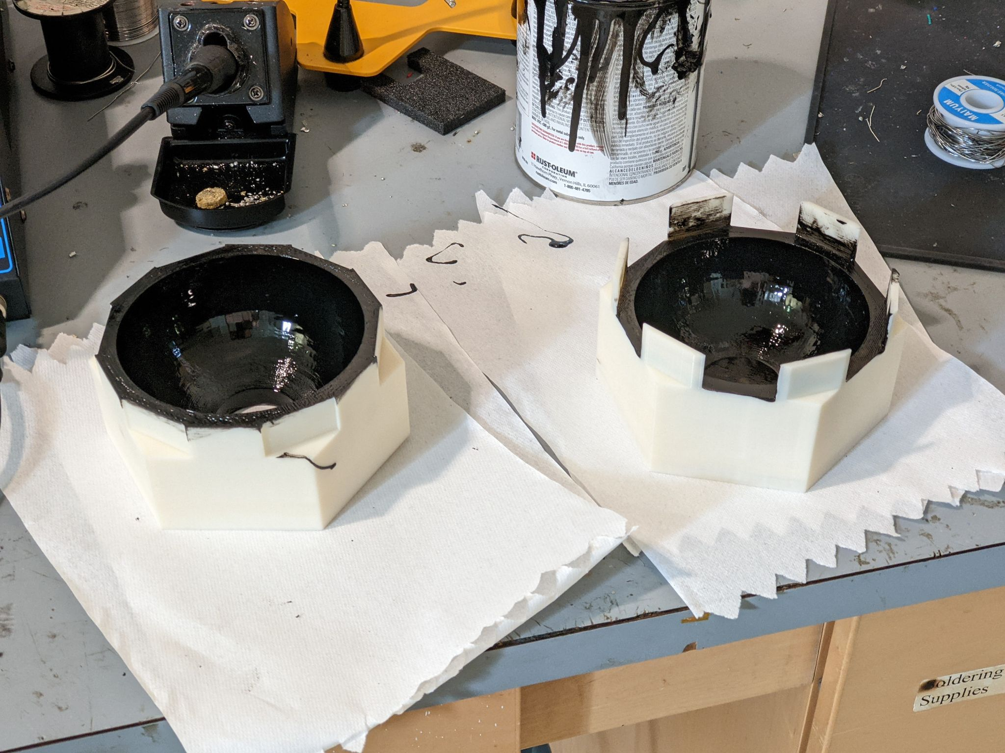

*Figure 3: Mold After Application of Enamel Coating*

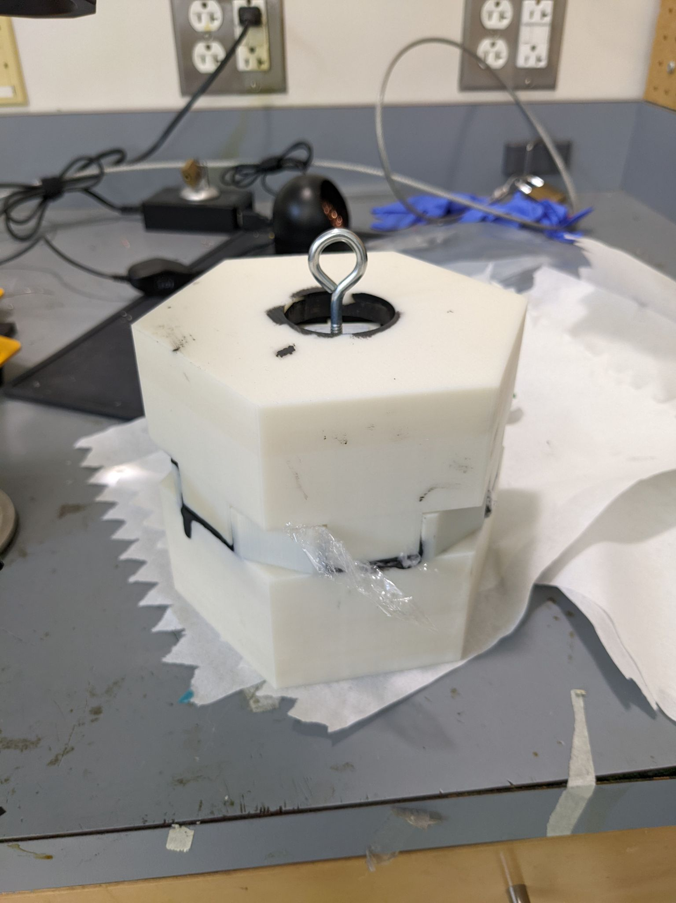

*Figure 4: Mold With Enamel Bleeding Visible and Plastic Sheet*

In parallel, we created a silicone mold for the epoxy. At the recommendation of our client, we began this process by 3D printing a mold of the negative space of the final mold. We then cast these negative molds using a two part silicone mixture, producing completely bleed proof forms for the epoxy casting. These silicone molds could then be filled with the skeleton and epoxy, creating the desired form. This is a more reliable alternative to the 3D printed molds, and these will be used for all following PUCKFish prototypes.

# 

Figure 5: Spraying Mold with Mold Release

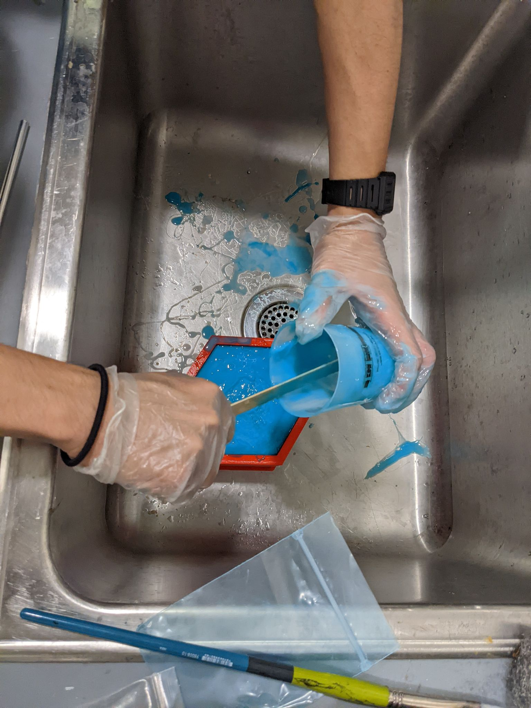

Figure 6: Pouring Silicone Mixture into Mold

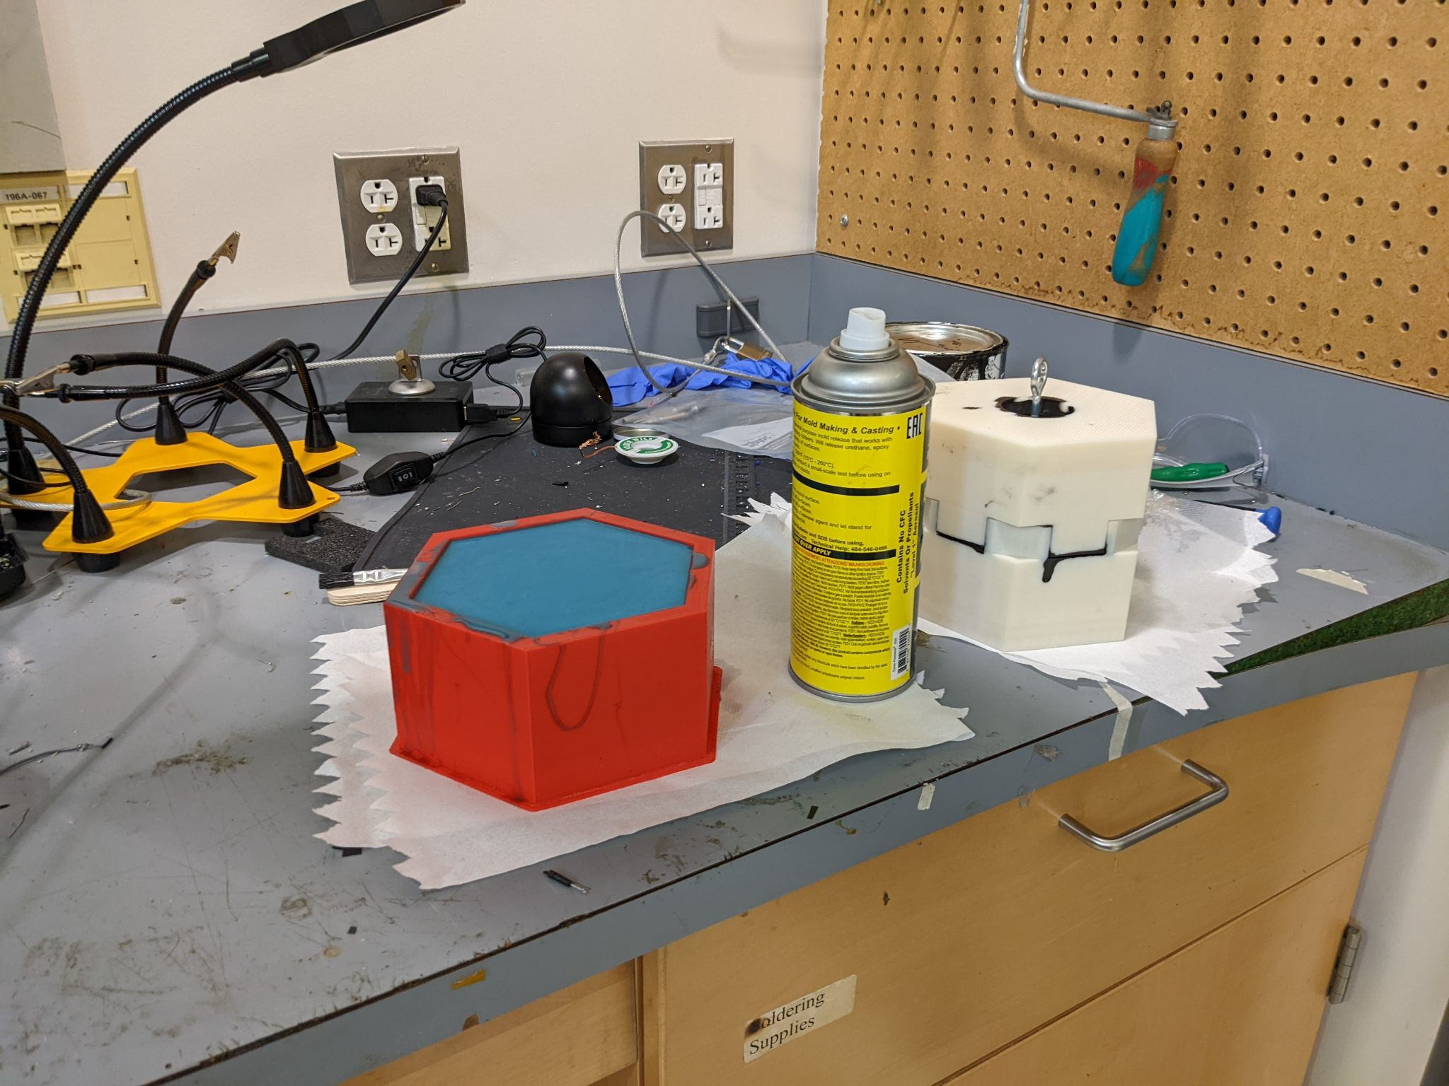

Figure 7: Mold Setting

# Results

While the epoxy continues to set due to the slow hardening time, each mold half was successfully cast without issue. While a more aggressive draft angle would have been ideal, the molds were removed after setting with only slight difficulty, and no damage. The final PUCKFish hardware prototype will be cast in these molds, and set over the coming week.

The epoxy cures extremely slowly due to the choice to use a slow hardener, which sets over the course of three days. This is somewhat inconvenient, but necessary, as a fast hardener would release significantly more heat, potentially risking the electronics cast inside. To additionally mitigate heat, we cast the part in approximately one inch layers, to prevent heat from being trapped internally, and causing a runaway exothermic reaction.

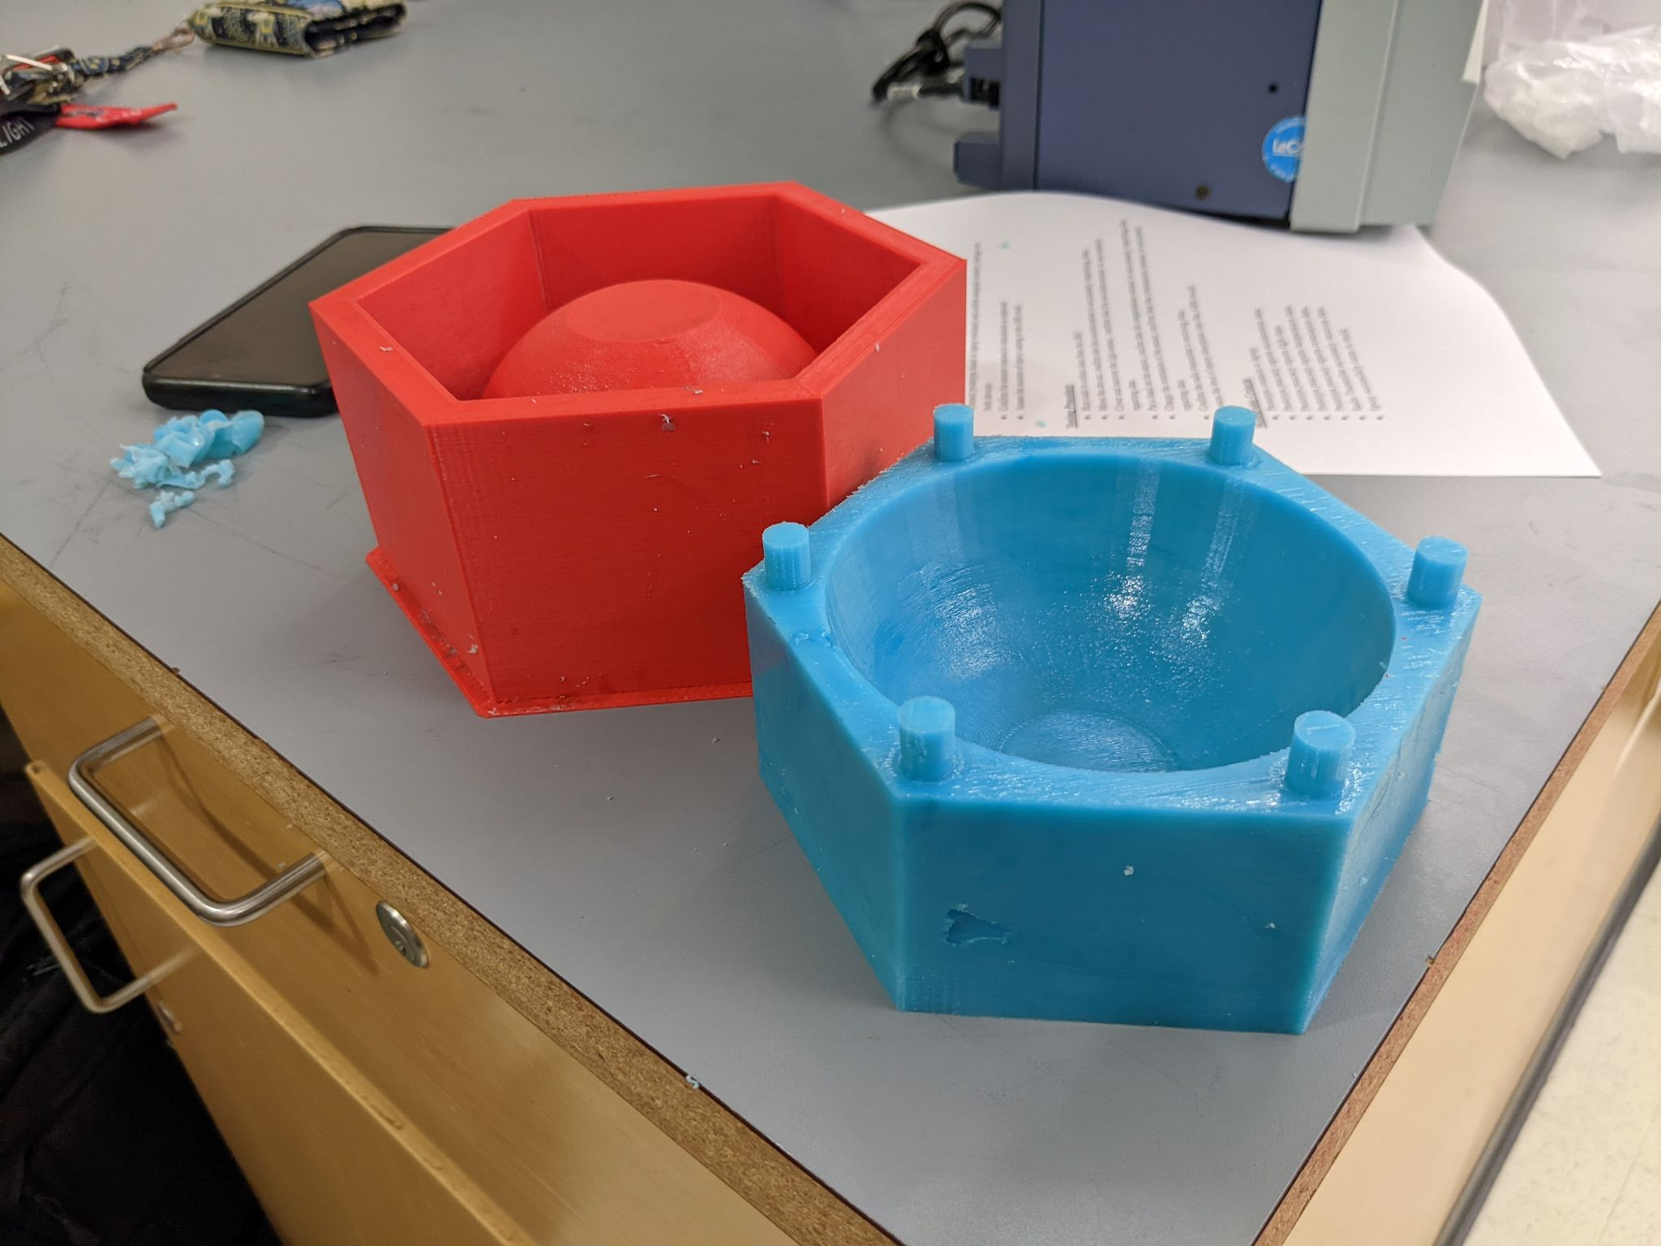

Figure 8: Final Cast Lower Mold

# Test 3.2: Partial Hardware Test

# Introduction and Overview

The goals for this test are as follows:

1. Prototype precisely reports acceleration data
2. Prototype precisely reports light data
3. Prototype precisely reports temperature data
4. Prototype precisely reports orientation data
5. Radio Transmitter accurately receives data

In order to test the success of our sensor system, we needed to test the accuracy of each individual sensor. At the time of this test, all of our sensors have been ordered. Unfortunately, due to supply chain delays and world events, our pressure sensor has yet to arrive. This being said, we can only test the hardware that has arrived: accelerometer, light sensor, temperature sensor, orientation sensor, and radio transmitter.

First, we moved the acceleration sensor and checked the data recorded. We then compared the data of the sensor while moving to the sensor while still, confirming that the acceleration sensor was effective. Second, we covered and uncovered the light sensor and checked the data recorded. We then compared the data of the sensor while covered to the sensor while uncovered, confirming that the light sensor was effective. Third, we placed a hand on the temperature sensor and checked the data recorded. We then compared the data of the temperature sensor while being warmed by the hand to the sensor while untouched, confirming that the temperature sensor was effective. Next, we changed the position of the orientation sensor and checked the data recorded. We then compared the data of the orientation sensor in position one to the sensor in position two, confirming that the orientation sensor was effective. Finally, we can confirm the success of the radio transmitter by receiving packets with a radio receiver and viewing the packets in a serial monitor.

# 

# Summary of Procedure and Required Equipment

| **OP 1: SETUP** |  |
| --- | --- |
| Op | Description |
| 1.1 | Connect radio receiver to laptop |
| 1.2 | Confirm Battery levels exceed 50 percent |
| 1.3 | Begin collecting data by starting up the IMU, Record the start time in the notes |
| **OP 2: TESTING PROCEDURE** |  |
|  | Description |
| 2 | Begin running the code for IMU according to best practice |
| 2.1 | Move the device, confirm that the accelerometer is accurately reporting data |
| 2.2 | Cover and uncover the light sensor, confirm that the accelerometer is accurately reporting data |
| 2.3 | Put a hand on the sensor, confirm that the temperature sensor is accurately reporting data |
| 2.4 | Change the orientation of the sensor, confirm that the orientation sensor is accurately reporting data |
| 2.5 | Confirm the radio transmitter is receiving data |
| **OP 3: TESTING PROCEDURE** |  |
|  | Description |
| 3 | Assess the level of epoxy absorption into the ABS mold |
| **OP 4: BREAKDOWN PROCEDURE** |  |
| OP | Description |
| 4 | Shutdown PCB per best practice |
| **OP 5: DATA COLLECTION AND ANALYSIS** |  |
| OP | DESCRIPTION |
| 5 | export data to a text file |
| 5.1 | Separate Data via the timestamps collected in ops 2.1-2.5 |
| 5.2 | Gather Averages of the data given in "TEST 2, DATA ANALYSIS" in this google sheet |

*Table 1: Procedure as Outlined*

After the procedure had been written the test could be run. However, after realizing that water could not be procured in the Senior Design lab during the test, the team decided to omit the underwater active portion of this test. Instead, this portion was performed after the data collection with success. In addition, by reviewing the data, it was determined that only a couple sample seconds from the test would be required, not orientation, to determine the path forward

The equipment requirements of the test can be seen below in *table 2*. This equipment was only listed for the active data collection portion of the lab as the other portions wrapped into the test were completed prior to the display in the senior design lab.

| **REQUIRED MATERIALS** |  |  |
| --- | --- | --- |
| Item | Name | Quantity |
| 1 | PUCKFish PCB V0.1 | 1 |
| 2 | PUCKFish Prototype Skeleton V0.1 | 1 |
| 3 | PUCKFish Prototype Mold V0.1 | 1 |
| 4 | Laptop (any) | 1 |
| 5 | PUCKFish Featherboard Receiver | 1 |

*Table 2: Materials List*

# 

# Results

During the test, the IMU and Light Sensor were placed onto the PCB with the microcontroller. The PCB was shifted to different orientations to demonstrate the acceleration and gyroscope working as intended. A warm object was placed on the temperature sensor to show the response of the temperature sensor. A dark object was placed over the light sensor to demonstrate it responding to a change in ambient light. All of these data were collected and output in JSON format through a serial monitor. This data was received by a radio receiver and also output through a serial monitor to verify fidelity of transmission. Below is the serial monitor output from the microcontroller directly connected to the sensors.

RF95 Initializing

RF95 Init success

RF95 Set frequency to: 915.00

MPU6050 Init success

BH1750 Init success

{

"timeStamp": 4689,

"accelerationX": 1.41257906,

"accelerationY": -0.44532153,

"accelerationZ": 8.853757858,

"orientationX": -0.022915773,

"orientationY": 0.115378261,

"orientationZ": 0.21450229,

"temperature": 27.58882332,

"ambientLight": 31.66666603

}{

"timeStamp": 9922,

"accelerationX": 1.673547029,

"accelerationY": -0.208295554,

"accelerationZ": 8.693346024,

"orientationX": -0.101522207,

"orientationY": 0.004130168,

"orientationZ": 0.013722817,

"temperature": 28.20058823,

"ambientLight": 32.5

}{

"timeStamp": 14989,

"accelerationX": 0.723048925,

"accelerationY": -0.256179571,

"accelerationZ": 8.621520042,

"orientationX": -0.021983154,

"orientationY": -0.011724349,

"orientationZ": -0.041701376,

"temperature": 28.24764633,

"ambientLight": 27.49999809

}{

"timeStamp": 20055,

"accelerationX": 10.13944435,

"accelerationY": 0.675164878,

"accelerationZ": -0.502782345,

"orientationX": -0.040369064,

"orientationY": -0.000133231,

"orientationZ": -0.070612557,

"temperature": 28.48294067,

"ambientLight": 32.5

}{

"timeStamp": 25121,

"accelerationX": 10.0460701,

"accelerationY": 0.284909993,

"accelerationZ": -0.579396784,

"orientationX": 0.007727412,

"orientationY": -0.161609486,

"orientationZ": 0.038370594,

"temperature": 28.48294067,

"ambientLight": 19.16666603

}{

"timeStamp": 30187,

"accelerationX": 0.287304193,

"accelerationY": -9.878476143,

"accelerationZ": -0.943315446,

"orientationX": -0.070612557,

"orientationY": -0.050094947,

"orientationZ": 0.009059724,

"temperature": 28.67117691,

"ambientLight": 15.83333302

}{

"timeStamp": 35254,

"accelerationX": 0.423773706,

"accelerationY": -10.01015759,

"accelerationZ": -1.242590666,

"orientationX": -0.023715161,

"orientationY": -0.038770292,

"orientationZ": -0.078073502,

"temperature": 29.04764748,

"ambientLight": 27.49999809

}{

"timeStamp": 40321,

"accelerationX": -0.306457818,

"accelerationY": -9.708487511,

"accelerationZ": -0.14844051,

"orientationX": 0.011457887,

"orientationY": -0.063284837,

"orientationZ": -0.038370594,

"temperature": 32.52999878,

"ambientLight": 27.49999809

}{

"timeStamp": 45388,

"accelerationX": 0.48362875,

"accelerationY": -9.210494041,

"accelerationZ": 0.584185243,

"orientationX": -0.218499228,

"orientationY": 0.029710567,

"orientationZ": -0.018918836,

"temperature": 33.42411804,

"ambientLight": 21.66666603

}{

"timeStamp": 50454,

"accelerationX": -1.213860273,

"accelerationY": -8.346187592,

"accelerationZ": 3.110068083,

"orientationX": -0.321353763,

"orientationY": 0.258601815,

"orientationZ": 0.092196018,

"temperature": 32.24764633,

"ambientLight": 23.33333206

}{

"timeStamp": 55522,

"accelerationX": 0.117315881,

"accelerationY": -9.56004715,

"accelerationZ": 0,

"orientationX": 0.027712099,

"orientationY": -0.009059724,

"orientationZ": -0.043966308,

"temperature": 31.63588142,

"ambientLight": 0

}{

"timeStamp": 60588,

"accelerationX": -2.942473888,

"accelerationY": -7.173028469,

"accelerationZ": 4.584896088,

"orientationX": 0.074609496,

"orientationY": -0.042101074,

"orientationZ": 0.006928025,

"temperature": 31.58882332,

"ambientLight": 0

}

*Table 3: Test Results*

## 

## Conclusion

Through reviewing the acceleration data, the format and data collection methods were determined as a success. By testing the enclosure in the bathtub, the water proofing portion of the test was also successful.

From the results of this test, it was determined that the best path forward is to begin modeling the gravity vector as well as buoyancy characteristics to form the quantifiable requirements for Test 2.1. The IMU showed response to orientation being changed rapidly with high fidelity as shown by time stamps 86s to 96s. In addition, by keeping the enclosure still, the IMU showed good results providing a steady value within the required amount of precision between times 98s and 118s.

The team also adjusted how data is collected, by using methods to separate strings from numbers using google sheets as opposed to a separate script written in MATLAB. From the results of the test, one portion of the team will get to work developing the model for the IMU Current test and another portion of the team will begin working on the sensor array for Test 2.1.

The team has accomplished the goals of Test 1.1 and feel confident in proceeding to the tests outlined in the plan discussed.

After overcoming some initial difficulties, the team was able to successfully cast a test skeleton in a mold, demonstrating its effectiveness. With the successful casting of the silicone molds, we are now ready to move into casting the final hardware in epoxy, and with that the final stages in prototyping our hardware.